**Get started with python**

**1st step**

**Download and Setup PyCharm for Learning\**

Download and install Python to your computer. Head over to the official Python website to download the latest version of Python for your computer system. Then complete the installation.

<https://www.python.org/downloads/>

**Step 2**

Download the Free Community Edition of PyCharm using the link below:

<https://www.jetbrains.com/edu-products/download/#section=pycharm-edu>

**IMPORTANT: If you already have PyCharm, make sure you update to the latest version of PyCharm**

**Step 3**

Once PyCharm installs successfully, you should see the welcome screen. Click on the Learn tab and click "Enable Access".

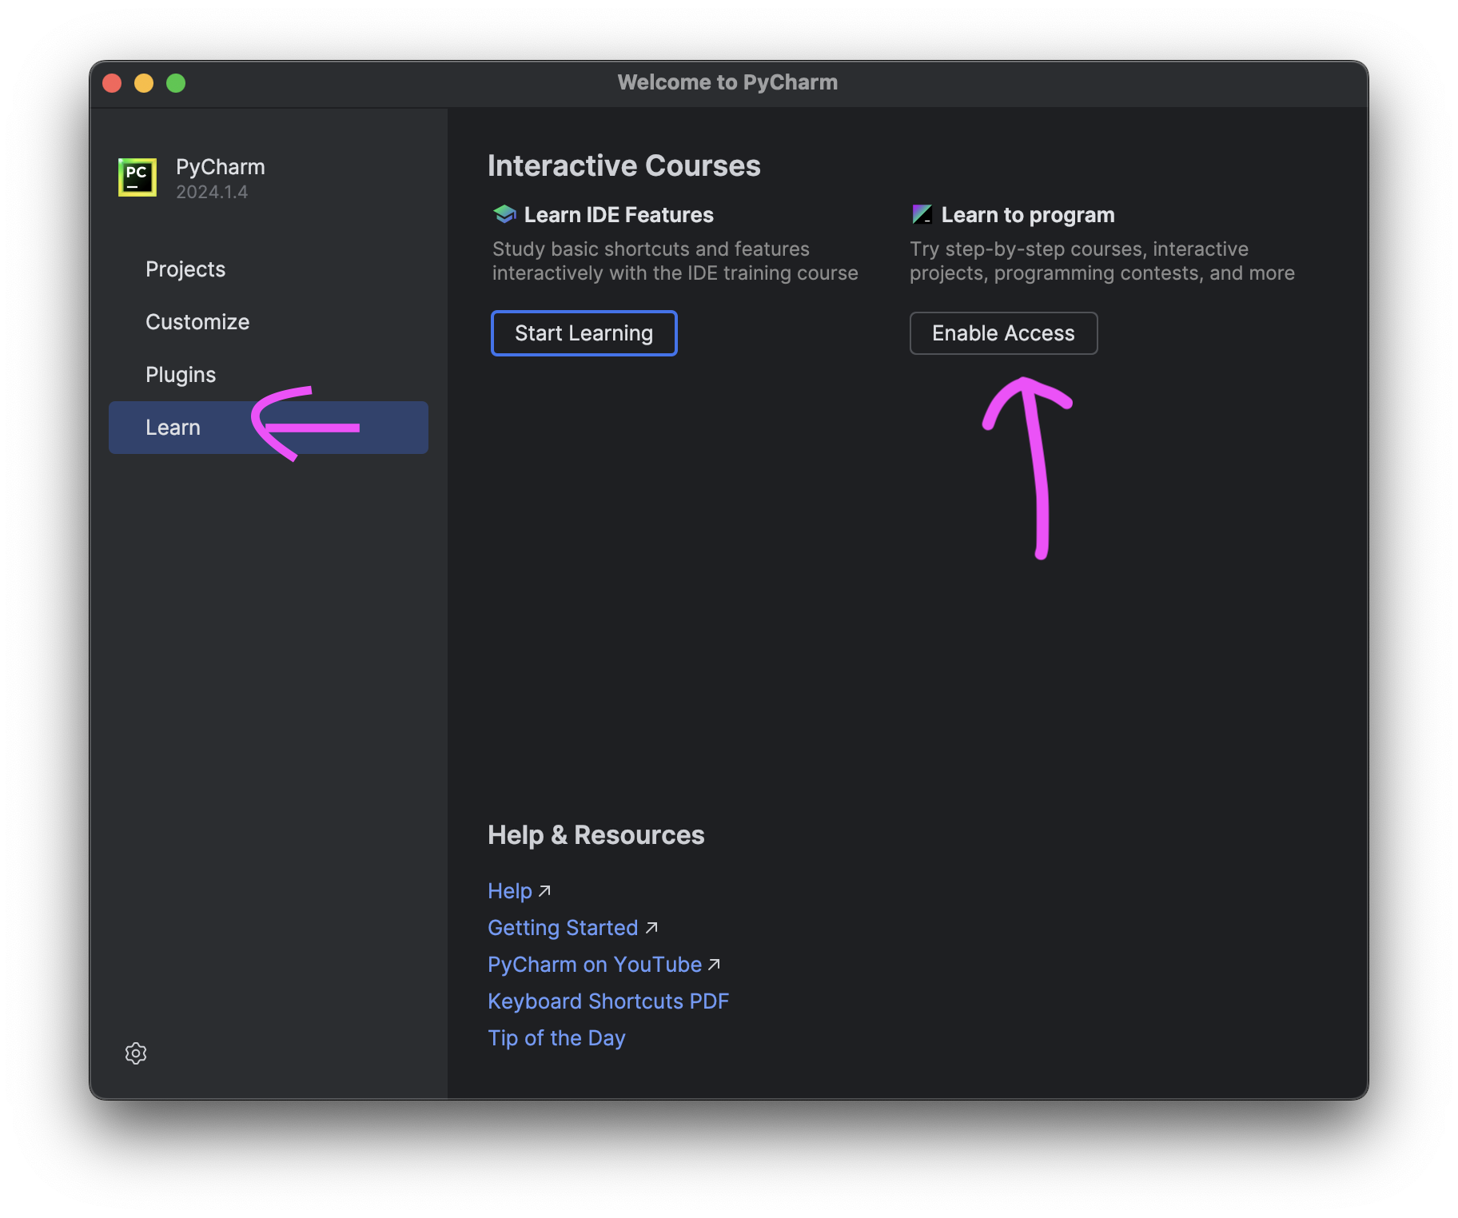

**Step 4**

Once all the required plugins install successfully. Close and Restart PyCharm.

**Step 5**

Head over to the link below and click "Open in PyCharm".

<https://plugins.jetbrains.com/plugin/25212-100-days-of-code--the-complete-python-pro-bootcamp?noRedirect=true>

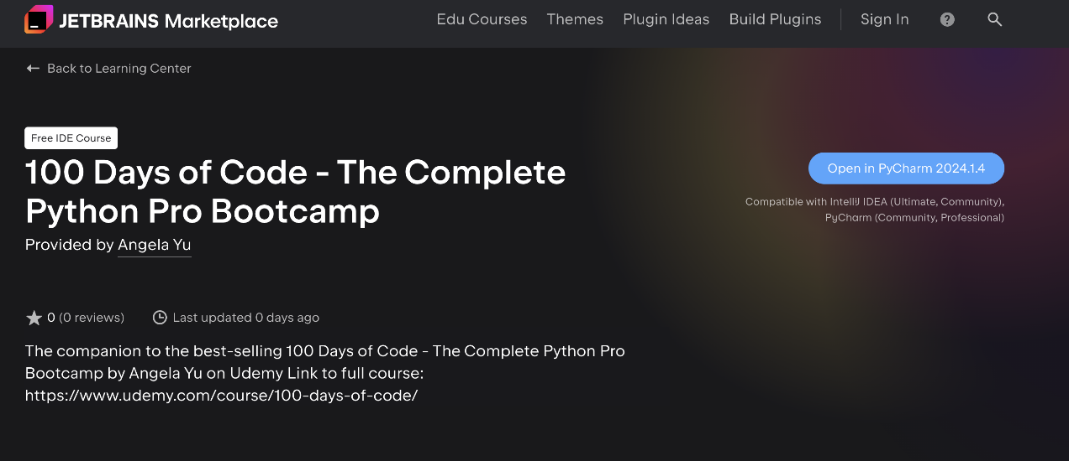

**Step 6**

It should take you directly to the course. If it does not work, you can also go to File -> Learn and Teach -> Browse Courses.

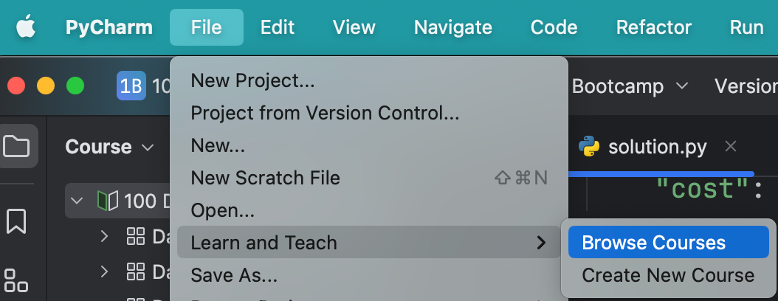

Next, scroll down to find the course: 100 Days of Code - The Complete Python Pro Bootcamp and click "Start". You can also search for it in the search course area.

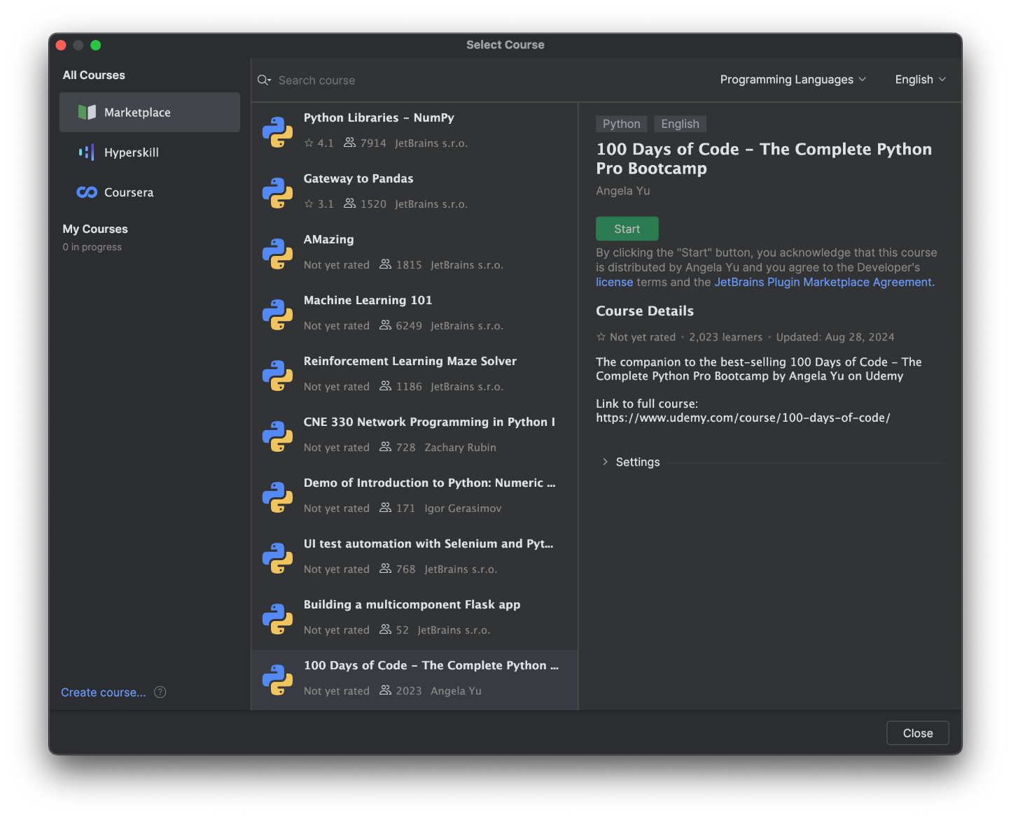

Now you should have access to the beginner course (Day 1 - Day 15) on PyCharm. You will be guided through the lessons to go from Task to Task (you can see the task numbers on the right pane e.g. 1 - 6 for Day1).

